

DEPARTMENT OF INFORMATION TECHNOLOGY
SCHOOL OF COMPUTING AND INFORMATICS

LOGBOOK: MOBILE APPLICATION DEVELOPMENT
UNIT CODE: BIT4107
NAME: YUSUF ANEMBA
REGNO: BIT/2020/90745
PROJECT NAME: MASENO WISDOM HOSTEL MANAGEMENT SYSTEM

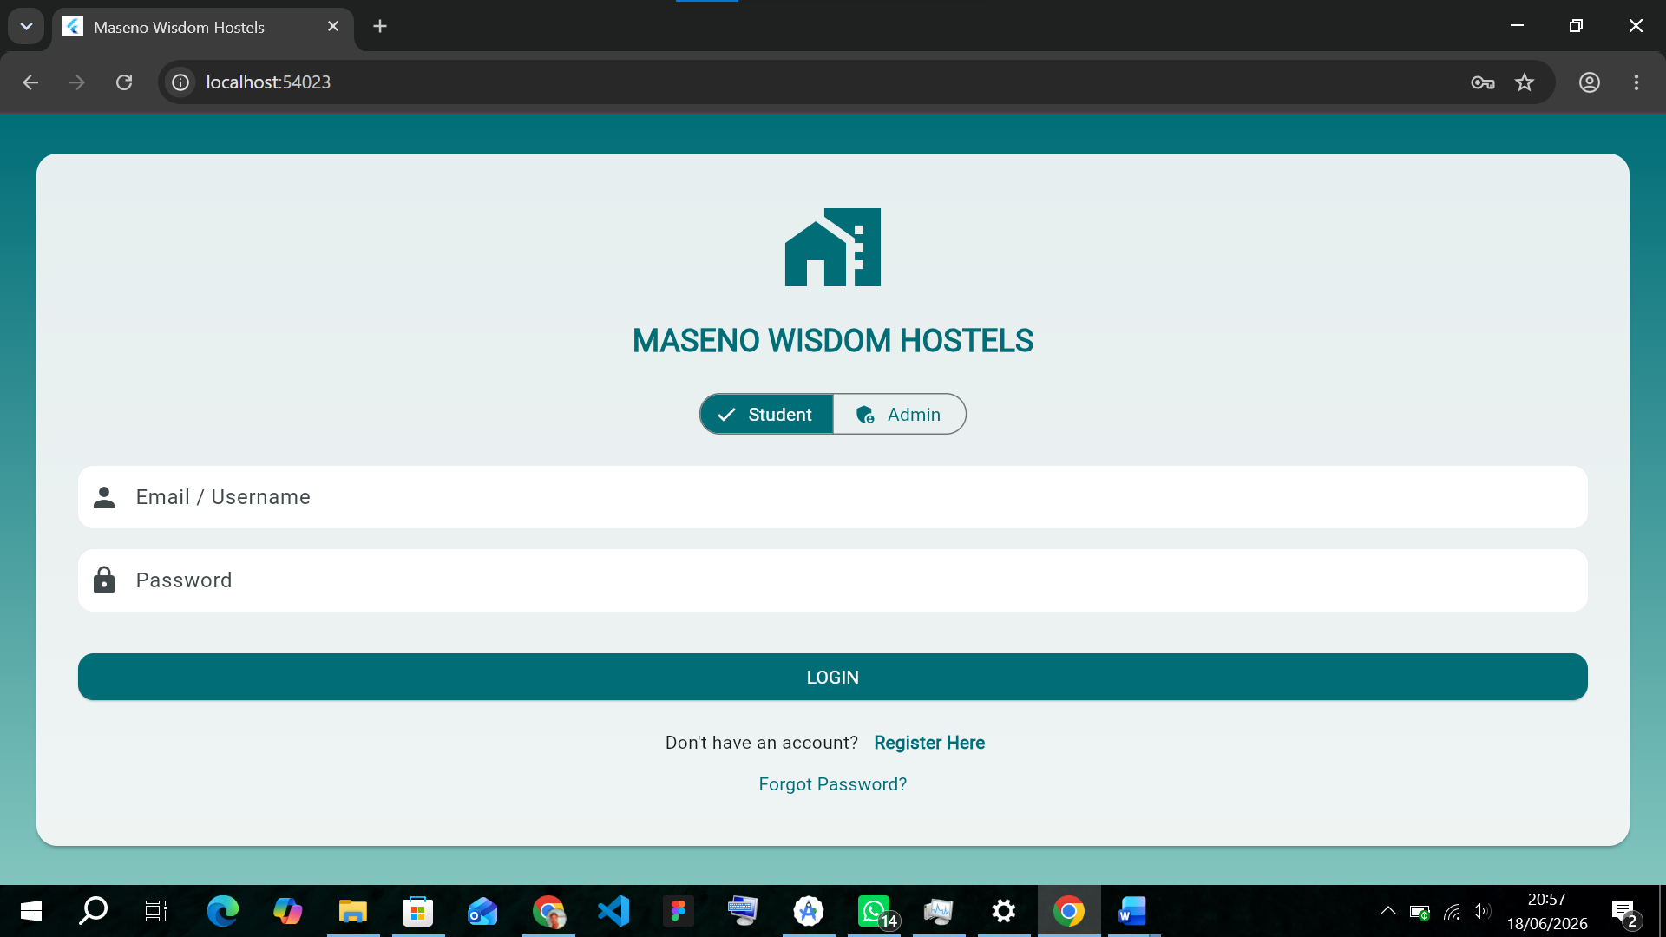
Figure 1.1 introduction screen to Maseno wisdom hostels
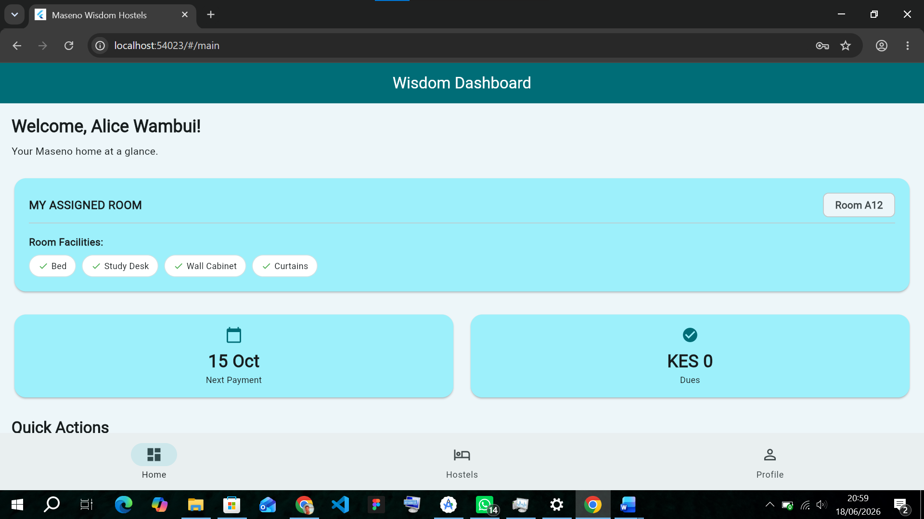
Figure 1.2 login screen for the students, to view their areas, assigned rooms and report any issues directly to the landlord.
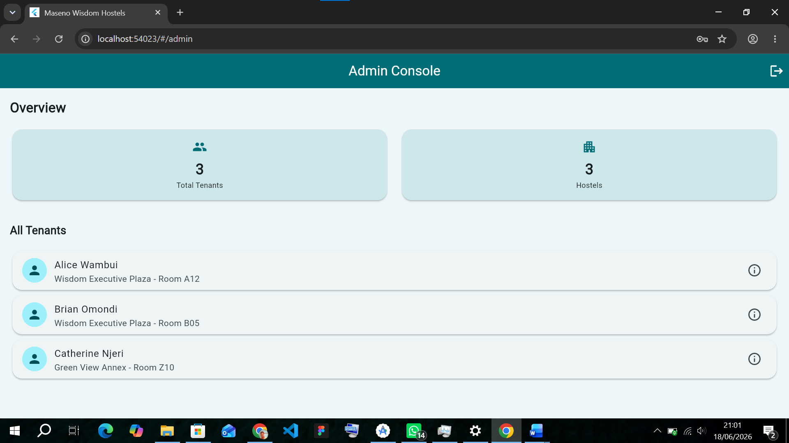
Figure 1.3 admin login page

TOOLS AND TECHNOLOGIES USED
For the development of the JAMHURI STUDENT MANAGENT APP, I used the following tools,
- Flutter
- Dart
- Android studio
- Android emulator/ my android phone

